TO: | Tara Weidner, ODOT
FROM: | RSG
DATE: | September 27, 2024
SUBJECT: | VE ITHIM Integration for Oregon VERSPM models
This memo is intended to demonstrate how to use VE ITHIM for VisionEval RSPM models using the Multimodal Module or the WFH module.

VE ITHIM Overview
The Integrated Transport and Health Impact Modeling Tool (ITHIM) is a tool developed to measure various health impacts across a geographic region. RSG has performed previous work to integrate ITHIM with VisionEval inputs and outputs that focused on five key health outcomes (all-cause mortality, diabetes, lung cancer, COPD, and road injuries), and produces health outcomes at the Bzone level.
ITHIM has the following data requirements, which are present in either ITHIM parameters or VisionEval demographic data:
- Population data: A synthetic population for modeling health outcomes.
- Trip data: Data describing travel behavior of the population.
- Baseline health status data: Data that characterizes the baseline health status of the population.
- Baseline exposure data: Captures exposures and/or behaviors that impact human health, both in the baseline and in modelled scenarios.
- Epidemiological/health risk data: Parameters that establish a relationship between an exposure and one or more health outcomes.
The VE ITHIM prototype model uses a series of subcomponents that load and harmonize data before developing health outcome estimates from the required data. For more information on these subcomponents, please read the document “VisionEval Pooled Fund ITHIM Integration Task 8.2_Final” for a separate case study and a more comprehensive model parameter review. The VisionEval Pooled Fund effort was a significant effort to refactor the ITHIM-R code into a more streamlined framework. The original ITHIM-R repo exists on GitHub at https://ithim.github.io/ITHIM-R/

Setting Up VE ITHIM for Reading VERSPM Models
Running the VE ITHIM model requires the following:
- Installation of VE ITHIM in a built runtime directory. VE ITHIM should be put in the “models” folder (this does not operate like VisionEval packge, the VE ITHIM folder only needs to be copied to the “models” directory, as opposed to being ‘installed’ like an R package.
Screenshot of Models directory
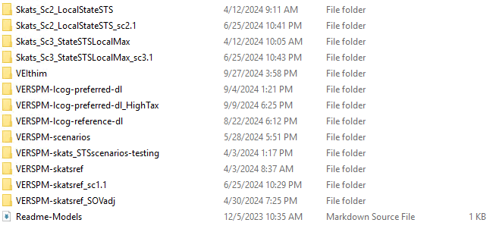

- Completed VisionEval model(s) to enter in the configuration files. Users should use the VE “export” function in the runtime environment to extract CSV results before using VE ITHIM.
- Copy the marea_safety_factors input into the folder “inst/extdata.” The model years in this input must match those specified in the configuration file. It is recommended to use a file with common years between the base and reference models.
This current iteration of VE ITHIM uses a “config.csv” file, located in the “inst/extdata” folder. This file allows the user to select the following options:
- Model_name: The name of the model being tested.
- Base_model: The model containing base year values (e.g. Using a model name a base year of 2020 will pull 2020 data from that model).
- Base_year: The base year of the base VisionEval model.
- Reference_model: The model being evaluated (how does the reference model future years compare to the base model year?). When using a multiscenario setup, select the scenario being tested.
- Crash_method: Defines which input data file to use when modeling traffic safety metrics. VE ITHIM analysis should use “ve.” This makes use of the crash factors in VETravelPerformance package.
- Type: Describes whether a multiscenario setup is being used. Ener “multi” if using a multiscenario setup, otherwise enter “single.”
Once this file is set with the correct parameters, users can open the “VEIthim” R project, open the script “RunITHIM.R,” and run all commands.

Analyzing Model Results
RSG has developed a custom script titled “results_compile.R” that is designed to compile all model results from the raw CSV outputs developed by the export function and VE ITHIM. This script should be run from the “scripts” folder in the model of interest. The results will be stored in the folder “results/output.” This script will generate two CSV files for VE ITHIM results: ithim_Bzone_results and ithim_summary. The former file contains a summary of all VE ITHIM outputs by Bzone, and the latter contains a summary of ITHIM outputs in the model region.
VE ITHIM Summary RESULTs File, Total Deaths – SKATS Scenario 3 vs Reference
Deaths - All Cause | Deaths – COPD | Deaths - Diabetes | Deaths - Colon cancer | Deaths - Traffic
-0.05315 | -0.00466 | -0.00332 | 0 | -3.39E-20
VE ITHIM Summary Results File, Years of life lost – SKATS Scenario 3 vs Reference
YLLS- All Cause | YLLS - COPD | YLLS - Diabetes | YLLS - Colon cancer | YLLS - Traffic
-1.12081231 | -0.086518192 | -0.077065034 | 0 | -1.41E-18

Potential Future VE ITHIM Improvements
- Improve traffic fatalities approach: The current approach does not consider contextual factors such as traffic safety countermeasures or environmental influences. However, estimated changes to crash rates can be implemented in VisionEval inputs.
- Complete all disease pathways: The current prototype model only uses 5 of the 21 potential disease pathways.
- Convert the prototype to a VE module: Further integrate ITHIM as a module in VisionEval.

